Class Diagram:

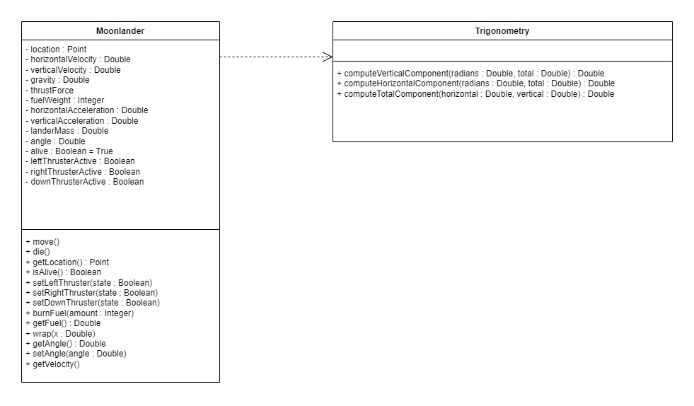

Structure Chart:

DFD:

Pseudocode:

move()

IF get_fuel() > 0

if left thruster

angle <-- angle + 0.1

horizontalVelocity <-- horizontalVelocity + 0.1

if right thruster

angle <-- angle - 0.1

horizontalVelocity <-- horizontalVelocity - 0.1

if down thruster

thrustAcceleration <-- thrustForce / (landerMass + fuelWeight)

horizontalVelocity <-- horizontalVelocity + Trigonometry::getHorizontalComponent(thrustAcceleration, angle)

verticalVelocity <-- verticalVelocity + Trigonometry::getVerticalComponent(thrustAcceleration, angle)

verticalVelocity <-- verticalVelocity - gravity

location.addX(horizontalVelocity)

location.addY(verticalVelocity)

setLeftThruster(state: Boolean)

IF get_fuel() > 0

leftThrusterActive = state

IF state

burnFuel(1)

Test Cases

Test cases for MoonLander::wrap:

|  |  |  |
| --- | --- | --- |
| Name | Input | Output |
| Left | X = -1 | X = 200 |
| Right | X = 201 | X = 0 |
| Middle | X = 100 | X = 100 |
| Far Right | X = -5 | X = 200 |
| Far Left | X = 262 | X = 0 |
| On Edge | X = 0 | X = 0 |

Test cases for MoonLander::isAlive

|  |  |  |
| --- | --- | --- |
| Name | Input | Output |
| Dead #1 | Ground: [5,7,11,9,10],  Location: [2,10] | False |
| Dead #2 | Ground: [6,7,10,8,14,16]  Location: [1, 7] | False |
| Alive #1 | Ground: [4,11,8,10,9]  Location: [4,15] | True |
| Alive #2 | Ground: [12,20,13,15,17]  Location: [0,13] | True |
| Alive #3 | Ground: [14,20,18,15,13]  Location: [3,21] | True |